**Date : 31-07-2020**

**Question :** First create a sub-directory named as your roll number under your user directory. Then create the following directory structure under your rollno directory.

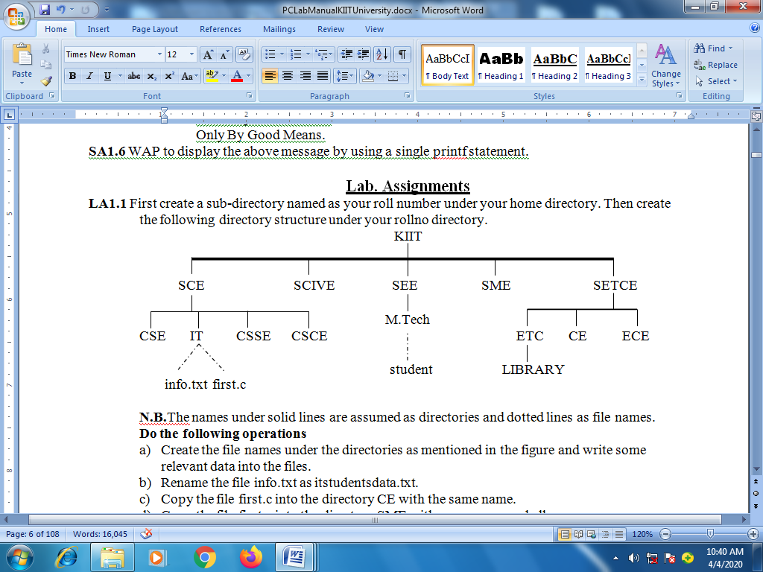

**N.B.**The names under solid lines are assumed as directories and dotted lines as file names.

### Do the following operations

1. Create the file names under the directories as mentioned in the figure and write some relevant data into the files.
2. Rename the file info.txt as itstudentsdata.txt.
3. Copy the file first.c into the directory CE with the same name.
4. Copy the file first.c into the directory SME with a new name as hello.c.
5. Transfer the file student into the directory SCIVE and check whether transferred or not.

Answer

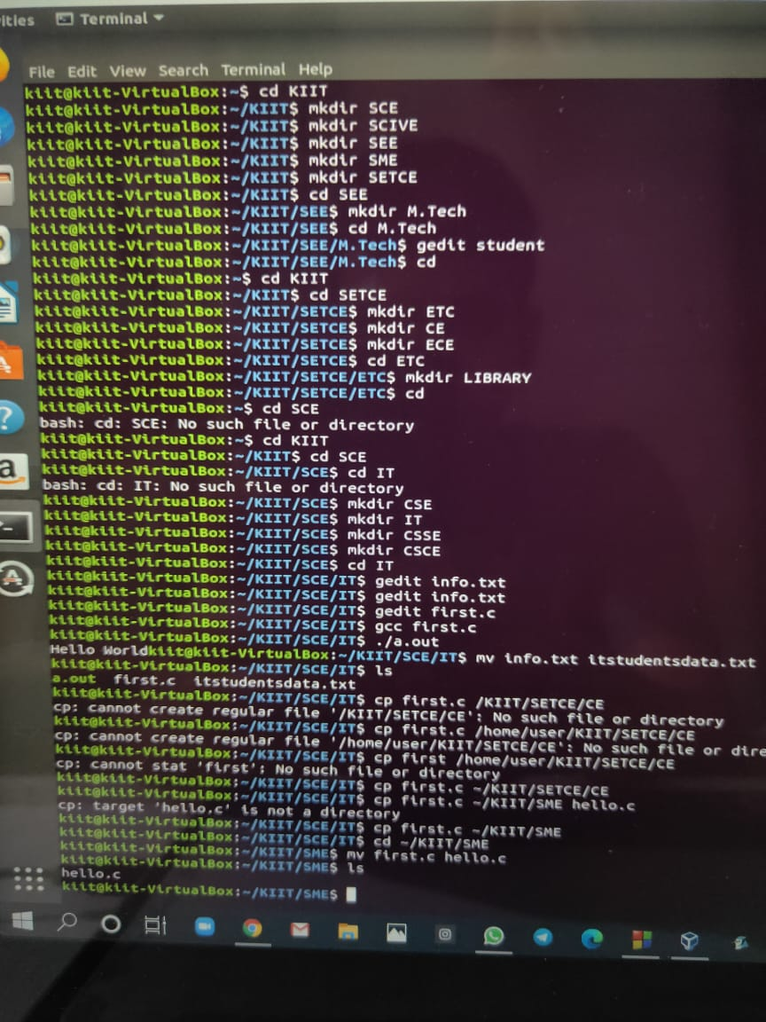

Lab Manual Questions :

1. WAP to input name, roll number and marks in 5 subjects for a student, and display it.

}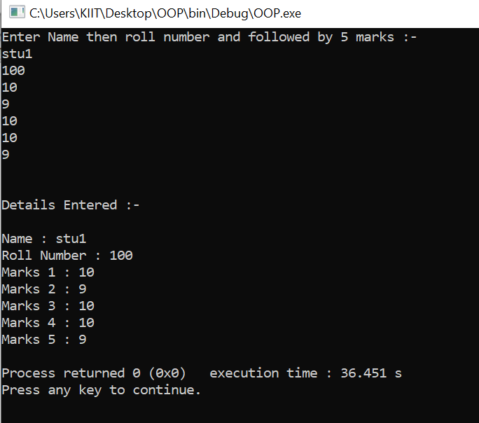

1. WAP to input name, roll number and marks in 5 subjects for n number of students. Write

functions to:-

a. Find total marks and percentage of all n students.

b. Display details of a student with a given roll number.

c. Display the details for all the students having percentage in a given range.

d. Sort the array in ascending order of marks.

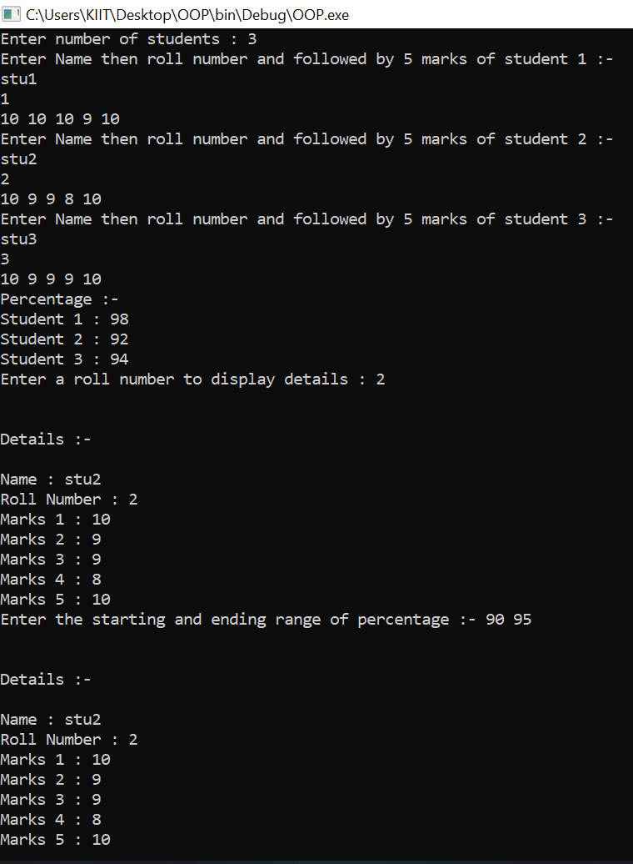 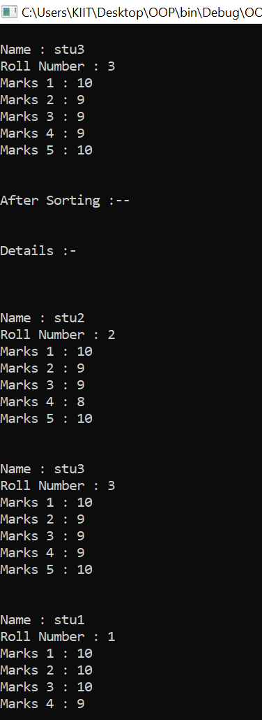

1. WAP to enter id, name, age and basic salary of n number of employees. Calculate the

gross salary of all the employees and display it along with all other details in a tabular

form, using pointer to structure.

[ Gross salary= Basic salary + DA + HRA,

DA = 80% of Basic salary HRA=10% of

Basic salary ]

